**VAISHALI BOKADIYA**

**PYTHON CODING CHALLANGE**

**QUESTION 1**

**Explain Pandas for Data Processing:**

Pandas is a library for python which is used for data processing. It provides data structures such as data frames and series and many functions to analyse and manipulate data.

**Execute Reading CSV Data using Pandas:**

CSV data can be read using the pandas.read_csv() method. It takes the filename as an argument and returns the data from the file.

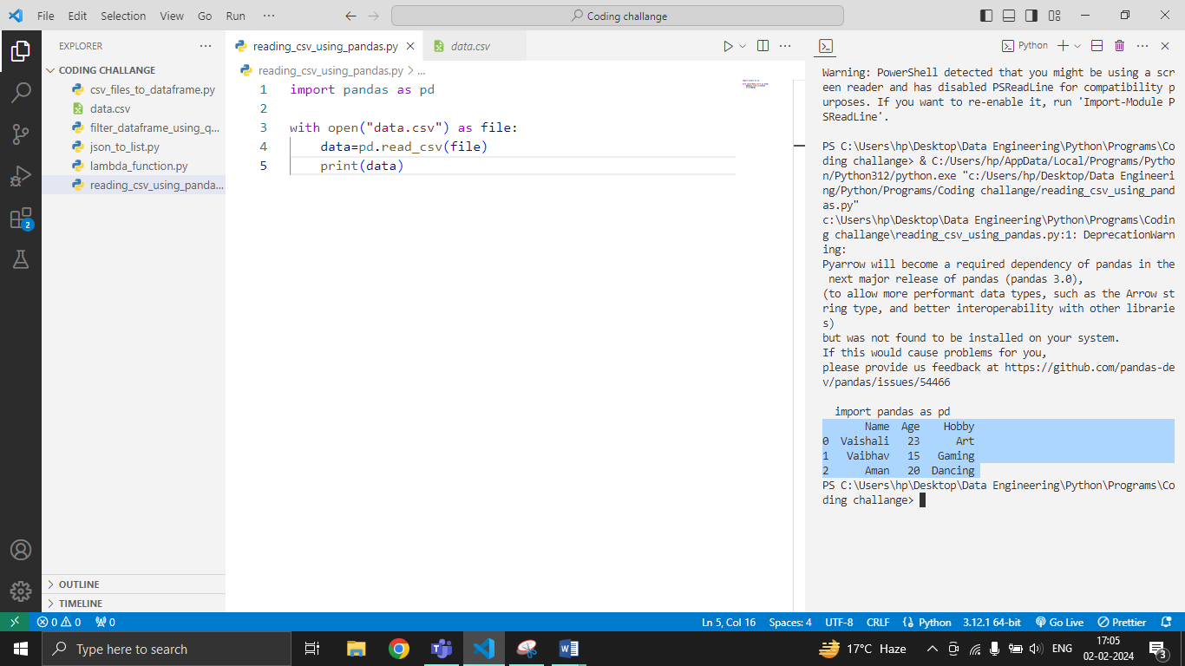

**Read Data from CSV Files to Pandas Dataframes:**

Data from CSV file can be read into Pandas dataframes using pandas.DataFrame() method. It takes data as the argument and returns the dataframe with the data in it.

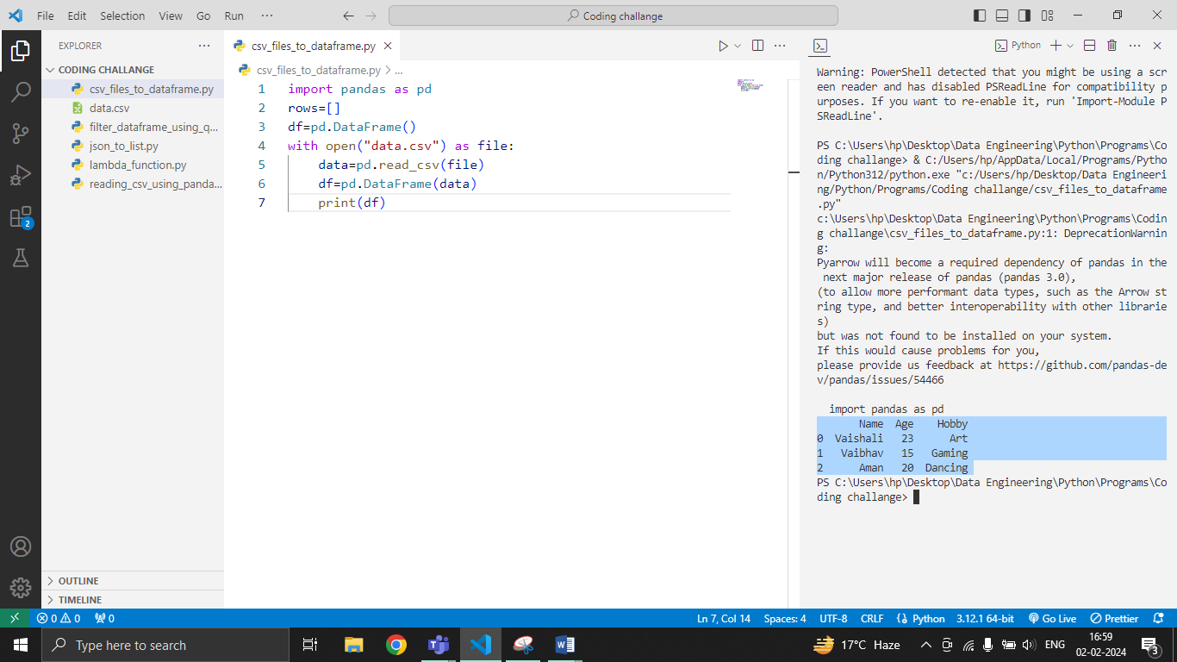

**Filter Data in Pandas Dataframe using query:**

Data can be filtered in Pandas dataframes using the query() method. It takes an argument, the filter condition in the form of string and returns the filtered dataframe.

